First part of the project is aimed at solving Schrodinger’s equations for one electron. The radial part of the Schrodinger’s equation is considered which is as follows

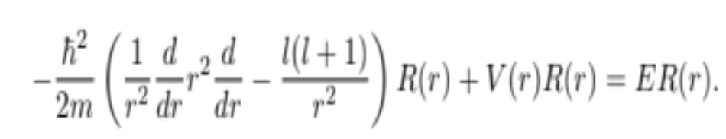 (1)
Inorder to solve this equation numerically, it is rewritten after a series of transformation and substitution as

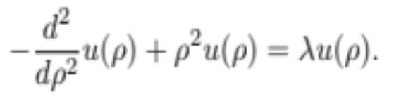 (2)
Equation (2) is discretized by assuming the second derivative of u

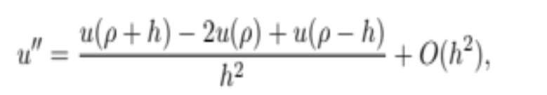 (3)
In eq (3) h is the step length, $ρ_{max}$ and $ρ_{min}$ are the maximum and minimum values of the variable $ρ$. For a given number of n _{step} , h is given by
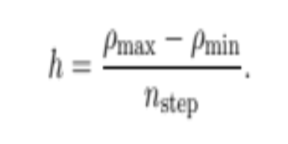
Inorder to solve equation (3) it is transformed into a matrix eigenvalue problem

Au = $λ$u (4)
Where A is a tridiagonal matrix of the form
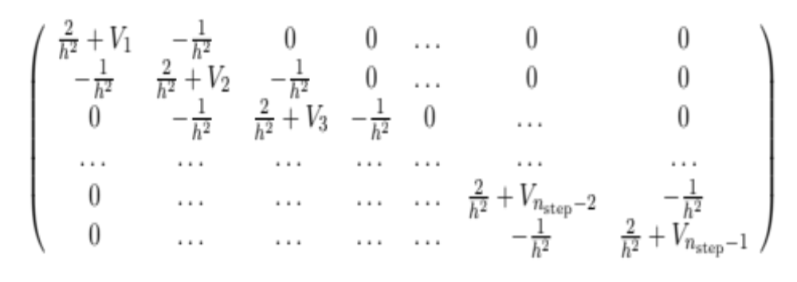
A is obtained from eq(3) by discretizing $ρ$ as

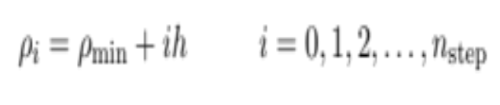
Now the Schrodinger equation becomes

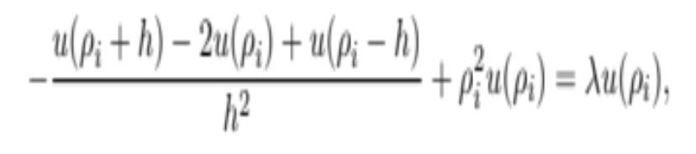
which can be rewritten as

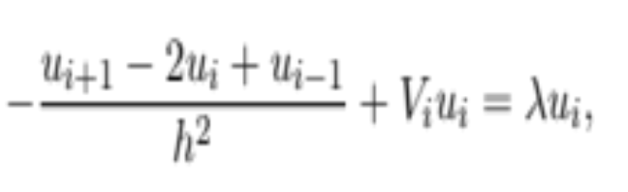 (5)
V_{i} = ${ρi}^{2}$ is the harmonic oscillator potential.
From eq (4) one gets the diagonal and non diagonal elements of matrix A as

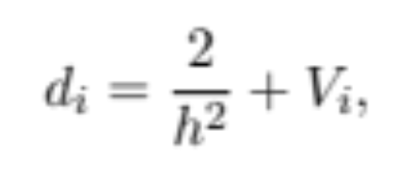
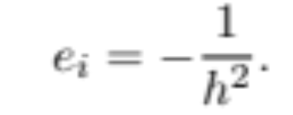 a mere constant

now equation (5) takes the form

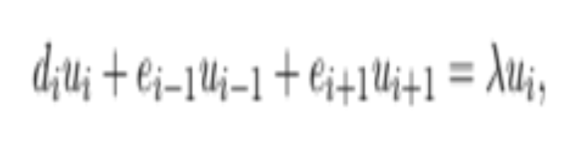
here u_{i} is the unknown. In order to solve for u_{i} we have the matrix eigen value problem of eq(4)

